**RESEARCH PAPER**

**Knowledge dialogues for better health: complementarities between health innovation studies and health disciplines**

José Miguel Natera 1

Soledad Rojas 1

Gabriela Dutrénit 2

Alexandre O. Vera-Cruz 2

1Cátedras CONACYT-Universidad Autónoma Metropolitana, Mexico

2 Universidad Autónoma Metropolitana, Mexico

Contact: josemiguelnatera@gmail.com

*Health innovations studies and the health disciplines highlight the importance of using knowledge to improve human welfare. However, these disciplines rarely yield discussion about this issue. The objective of this paper is to establish a dialogue between health innovation studies and the health disciplines, and to reveal the complementarities among these approaches. We present a revision of selected models of health knowledge use. From health innovation studies, we consider two models focused on the nature of health innovation, and two others that orient health innovation studies towards addressing inclusive development issues. From the health disciplines, we analyse translational research and knowledge translation models. Using a systemic perspective, we structure our analysis of complementarities on four analytical dimensions: (i) the actors, proposing the recognition of the public sector, the productive sector, the scientific community, and health services providers; we also define two dynamic actors: knowledge users and knowledge beneficiaries; (ii) the interactions, considering them as asymmetrical to facilitate knowledge flows; (iii) the process, based on specific models of healthcare activities and a broad set of validation mechanisms (not only market-related); and (iv) the institutional framework, proposing consideration of formal institutions (e.g., regulations) and informal institutions (e.g., socio-cultural background).*

# 

# Introduction

Health knowledge production, transfer and application are of upmost importance for ensuring human welfare. In this paper, we focus on the use of these concepts in two branches of the health literature: (i) the systemic perspective of innovations studies as applied to the health sector which we call “health innovation studies” and; (ii) translational perspectives, originating in the health sector which integrate disciplinary experience, here named “health disciplines”. These two branches explicitly recognize the importance of knowledge for better health; however, they barely interact with each other. In line with this we wonder: what are the similarities and complementarities between these two approaches to health knowledge application? In this paper, we outline some answers to this question. We do not aim to present a systematic literature review and we are allergic to monolithic analytical frameworks. We suggest that the complexity of the health sector does not warrant *one-size-fits-all* visions and, in contrast, we argue that the construction of analytical frameworks in the health sector should be problem and context specific. Therefore, our goal is to offer conceptual input by pointing out relevant connections between these two approaches. Our intention is to encourage an open evolving discussion in the scientific community and, in order to do so, this paper presents a critical assessment of points of contact between these fields using selected models as a foundation. Thus, the objective of this paper is to establish a dialogue between health innovation studies and the health disciplines and to reveal complementarities between them.

Our objective is justified for two reasons. First, from a theoretical perspective, it is necessary to have a better characterization of healthcare activities. Health innovation studies would benefit from integrating a deeper understanding of the dynamics and determinants of health activities to foster the use of knowledge. The health disciplines would also profit from considering the productive systems around their activities when providing new solutions. Second, even though knowledge derived from research has always been fundamental for the implementation of new health solutions and practices (WHO et al., 2013), interest in proposing formal models that focus on developing the processes to allow the transferring, adopting and implementing of health knowledge is relatively recent. Consequently, in practice, these processes normally do not benefit from sound guidance or they do not have a defined critical path which leads to longer lead times to materialize results (González-Block, Mercado, Ochoa, Rivera, & Idrovo, 2008).

Section 2 of this paper presents the analytical framework that structures our analysis and briefly explains how we identified the models that are included. Section 3 contains a review of influential models of health innovation using two models focused on products and services and two others that orient health innovation towards addressing inclusive development issues. Section 4 characterizes health disciplines models for knowledge use, namely, the Translational Research (TR) and Knowledge Translation (KT) models. In section 5, we present the four dimensions of this dialogue between health innovations studies and health disciplines. Finally, we draw out the conclusions resulting from this exercise.

# Proposing analytical dimensions and identifying models for knowledge use in health

In this section, we discuss the structure of our study and the way we identified the models that will be analysed. Due to its substantial complexity, there is no consensus about the analytical dimensions to frame health knowledge use. Instead of pursuing that impossible task, we propose using the Innovation Systems (IS) framework as a point of departure. IS offers constructs developed as action tools and analytical frameworks to understand how science, technology and innovation (STI) take place in different contexts (Lundvall, 1992). Because of its flexibility and systemic perspective, we propose that IS are suitable to structure how health knowledge could be used (Cassiolato & Lastres, 2007; Consoli & Mina, 2009; Hanlin & Andersen, 2016). Although there is a vast literature characterizing IS-using nations, regions or sectors as units of analysis, there are four analytical dimensions that are constitutive of this tradition (Natera, Suárez, & Rojas-Rajs, 2017):

* **The actors**: Freeman (1987) identifies institutions of the public and private sectors as the main actors in STI processes. However, in a broader conception, there is room for the inclusion of other actors (Lundvall, 2016): specifically, there is a recent tendency to incorporate the civil community as an IS key player (Cozzens & Sutz, 2014; Dutrénit, Natera, Anyul, Vera-Cruz, & Torres, 2018; Etzkowitz & Rickne, 2014).
* **The interactions**: interactions between actors ‘initiate, modify, and disseminate new technologies’ (Freeman, 1987, p. 1). The relationships and linkages that are established through actors’ continuous exchanges allow knowledge flows and synergy creation (Niosi, Saviotti, Bellon, & Crow, 1993). These interactions are hierarchical and they depend on power relationships based on capabilities and institutional asymmetries (Dutrénit et al., 2018).
* **The process**: this dimension includes: (i) the learning process in which actors modify or create new useful products, methods or services (Lundvall & Johnson, 1994), considering that different modes of learning (by doing, by using and by interacting) take place on different levels (Lundvall, 1996); and (ii) the innovation validation process which is normally represented by market mechanisms, but not limited to them. We will argue that there are other validation mechanisms in the health sector that represent knowledge application in terms of non-private utility (OECD/EUROSTAT, 2018).
* **The institutional framework**: the ‘rules of the game’ are a main part of an IS (Nelson & Nelson, 2002). The way in which actors are organized will boost or delay the possibility of using knowledge (Nelson, 2008). These rules determine how social technologies emerge and the new possible avenues to incorporate STI solutions in different contexts. We consider formal institutions (explicit and codified) and informal institutions (implicit and tacit).

Identifying relevant models to include in the analysis comes with some compromises. There are many available options and various literature reviews recommend a set of interesting models (Greenhalgh, Robert, Macfarlane, Bate, & Kyriakidou, 2004; Tugwell, Robinson, Grimshaw, & Santesso, 2006; Vinot et al., 2012; Yazdizadeh, Majdzadeh, & Salmasian, 2010). Since we do not aim at proposing a systematic literature review, we follow two ad-hoc strategies for model identification.

For health innovation studies, we proceeded as follows: (i) we listed all documents presented during the last 10 years of the Globelics[1] conferences; keywords were searched in titles and abstracts with the aim of identifying the authors and proposals focused on studying the relation between health and STI, using a systemic framework; (ii) we reviewed the most cited papers and their centrality - in order to know the most relevant documents using as criteria the number of citations in Google Scholar and, when applicable, the quality of the journal in which it was published; and (iii) we selected models based on their different approaches to the subject. We are aware that because of the Globelics community’s interests, our analysis is biased toward development issues, but we decided to follow this road since health inequalities are present in developing and advanced countries (Marmot, 2005). For the health disciplines, we took a different road. The proposals of KT and TR have been exported throughout the world by international organizations and they propose incentives, mechanisms and specific institutional tools to develop projects under these perspectives.

Based on these strategies, we selected four relevant models in health innovation studies and three models in the health disciplines. In the next two sections, we describe how each of these models works and we frame them using the four analytical dimensions described above (actors, interactions, process and institutional framework).

# Health innovation studies

Not surprisingly, healthcare has been identified as an area in which STI might have a strong impact on development issues (Johnson & Andersen, 2012). In the following, we describe four models from health innovation studies. First, we present two general models that allow us to understand how healthcare products and services are conceived (*Health Innovation System oriented towards delivering new products,* and *Innovation in health services*). Then, we introduce two models oriented to knowledge application in developing countries, offering a contextualized space to understand the possibilities of using STI for the inclusion of marginalized communities (*Global health social technologies,* and *Local Innovation and Production Systems in the health sector*).

**Understanding the nature of healthcare innovation**

In the innovation literature, healthcare is defined as a sector; therefore, we would expect it to be configured according to the premises of sectoral innovation systems (SIS) (Malerba, 2002). However, the complexity of healthcare activities is such that its analysis normally drives the conceptual framework away from the regular SIS analysis.

We can give at least three reasons to explain why healthcare does not fit into a regular SIS analysis (Ramlogan et al., 2007): (i) the healthcare sector is very diverse and since innovations are not necessarily executed by firms, it is not easily typified by international classifications of economic activities (such as NACE, ISIC or NAICS); (ii) the number and nature of the actors that are involved are greater than in other sectors, for instance, hospitals, health institutions, regulation institutions, patients and other healthcare services providers are quite heterogeneous; and (iii) the burden of the institutional framework is considerable and it has a substantial impact on the introduction of new knowledge based applications.

* ***Health Innovation System oriented towards delivering new products***

Consoli and Mina (2009) propose a model of the Health Innovation System where the generation of new products is at the core (Figure 1). It is comprised of two building blocks -considered as the models’ *gateways*- which represent the transition in the development of new technologies to their incorporation into medical practice. At the top of the model, they place the interaction between Science and Technology, represented by the *Scientific Community*, and focused on the generation of publications that reflect new knowledge (new treatments, diagnostics methods, products’ effectiveness), and the *Technology Market* which provides new pharmaceutical developments and new medical devices. At the bottom of their model, there are two spheres: *Service Provision* and the *Individual Sphere.* The first mostly takes place at a hospital or at other clinical centres where diagnosis and therapeutic treatments are delivered to patients. The second is where the patient’s problem and the practitioner interact.

The model’s *pathways* are represented by the virtuous triangle that links the top and the bottom of the scheme. It is mainly fuelled by the interaction (in research projects and other regulatory affairs) between the clinicians and the scientific community, and by the dynamics of knowledge production in the health sector. Based on an evolutionary perspective (Metcalfe, James, & Mina, 2005), Consoli and Mina (2009, p. 309) propose that ‘the incremental search for improvements, combined with the feedbacks generated by their application, give way to trajectories of problems and solutions’, generating a problem-sequence that dynamically contributes to the generation of a re-appreciation of knowledge, and that ultimately defines technological trajectories (see Dosi, 1988). *Regulation* is represented as a sphere placed between the two building blocks; it has an influence on the rate and direction of health innovation (by setting priorities or defining fund allocation).

**Figure 1.** Consoli and Mina's model of Health Innovation System

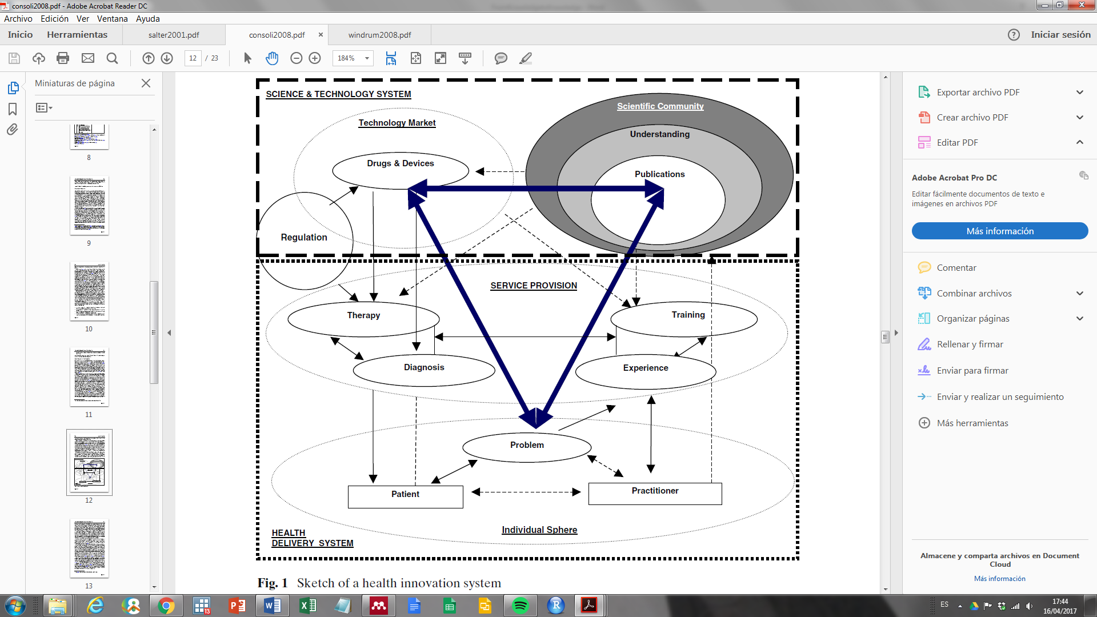

*Source: Consoli & Mina (2009)*

* ***Innovation in health services***

Windrum and García-Goñi (2008) designed a model to study innovation in health services aiming at appraising the complexity of healthcare by incorporating social and political considerations in a neo-Schumpeterian framework. Their model is based on previous work by Saviotti and Metcalfe (1984) and Gallouj and Weinstein (1997).

At the centre of Figure 2, we find *Service characteristics* which are determined by the interaction of three types of actors: service providers, policy makers, and users. Each actor is involved systemically in an interactive process between their preferences and competences. *Competences* are defined as a combination of: (i) intangible and tangible assets, and (ii) human and organizational resources. Service providers are public or private sector institutions that perform healthcare activities. Policy makers contribute a set of resources that is provided by their roles and experience. Patients, on the other end, have a network of social relations that, combined with their own capabilities, might guide their possibility to perform specific tasks in the definition of health services. *Preferences* embody social and political aspects of the actors in the model. There is no clear definition of preferences in Windrum and García-Goñi’s paper; but it can be inferred that they reflect the actors’ willingness, interests and desires to adopt a particular health service given their experiences, knowledge and social backgrounds. Preferences are the source of possible conflicts and negotiations that may modify services characteristics and, over time, the technological trajectories.

The interaction between actors’ preferences and competences is what defines the health services’ characteristics. Health services are a synthetic construct that represents a balance between actors’ capabilities and interests. Consequently, they are necessarily dynamic and are expected to evolve and adapt to actor changes. At the same time, actors change according to the new services they find, how they interact with them and the benefits they perceive from them. This co-evolutionary process qualitatively alters the system and defines the trajectories it will follow.

**Figure 2. Windrum and García-Goñi’s health services innovation model**

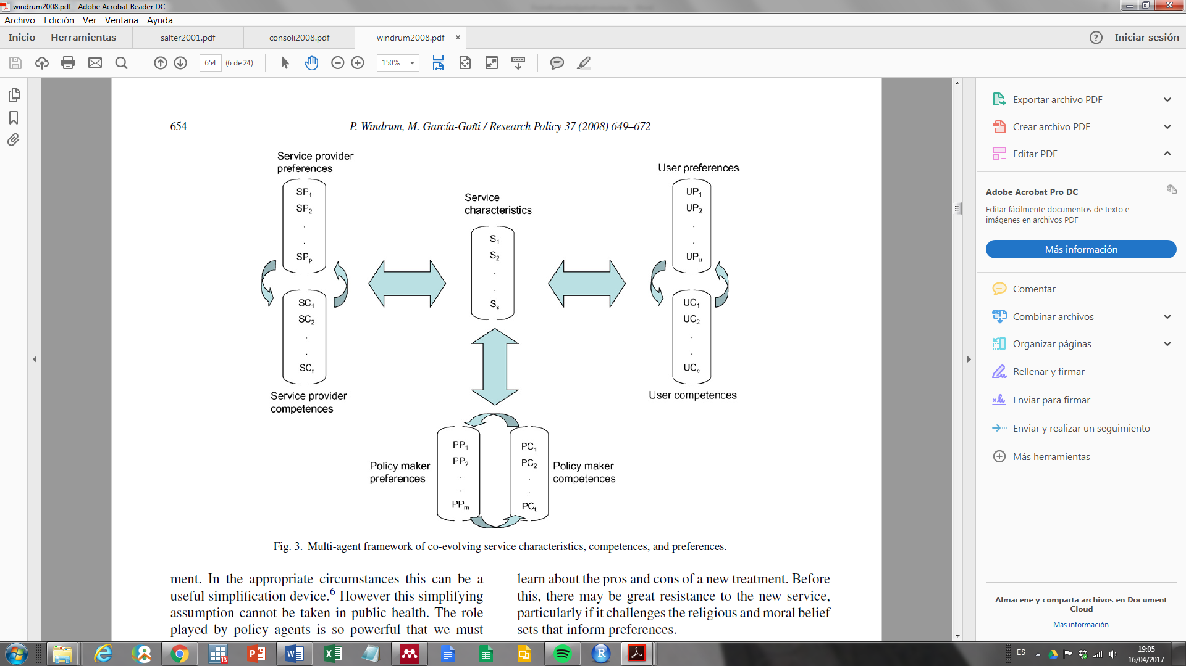  
Source: Widrum and García-Goñi (2008)

## Health innovation for inclusive development

Inclusive health innovations models are rooted in the idea that in modern societies people’s health conditions are factors that express economic and social development levels (Sáenz, 2015; WHO et al., 2013). Therefore, STI on healthcare has an enormous potential to produce a positive impact on development issues. We present two main streams for inclusive health innovations: one that starts from the advance of technology on a global level and another that considers the development of local capabilities.

* ***Global health social technologies***

The model called ‘Global health social technologies’ proposes adapting STI generated in more technologically advanced regions into solutions (products and services) for less advanced countries (Chataway, Hanlin, & Kaplinsky, 2014). Context consideration is fundamental because it is necessary to observe local specificities (social, cultural, geographical conditions) to achieve a successful insertion of products and services in people’s ways of living.

Innovation is described as a process in which physical technologies and social technologies[2] co-evolve (Nelson, 2008; Nelson & Sampat, 2001). According to Chataway et al. (2010), in health activities: (i) knowledge embedded in physical technologies is normally produced following Gibbons’ Mode 2 (Gibbons et al., 1994); in other words, social technologies based on knowledge production that is oriented towards a practical application and that comprises multidisciplinary approximation with a great diversity of multifaceted actors; and (ii) social technologies imply agencies involving actors that should be able to restructure the way they organize themselves to generate their own solutions.

Through social technologies, physical health technologies (generated on a global scale) can be used to solve problems in countries with inclusion issues. By focusing on their adaptation, many physical technologies (and the embedded knowledge they hold) can be transferred to less favoured contexts if the institutional framework allows for this. The strategy involves the formation of ‘Product Development Partnerships (PDPs)’, where the actors that own the technologies (national or foreign companies, public sector, academic sector) can interact with sectors affected by exclusion conditions and jointly develop solutions tailored to their needs (Chataway et al., 2010).

PDPs are the social technologies required for adoption, adaptation and intermediation among actors involved in the innovation processes. The PDPs’ capability to achieve knowledge circulation and information sharing is a key element to align STI objectives and to achieve inclusive health solutions. In addition, PDPs can be configured as public-private alliances in which the productive sector and governments are able to generate new capabilities while solving health problems.

* ***Local Innovation and Production Systems (LIPS) in the health sector***

In the ‘Local Innovation and Production Systems (LIPS) in the health sector’ model (Soares Couto & Cassiolato, 2013), developing local capabilities is crucial when generating solutions to health problems in an inclusive manner. As shown in Figure 3, one fundamental characteristic of LIPS is the consideration of actors and their interactions around productive activities, since they are strongly interconnected and articulated with the institutional framework (Cassiolato & Lastres, 2000). LIPS frames their analysis within a geographical dimension, including diversity in terms of political, economic and social actors and activities; considering tacit knowledge, interactions between innovation and learning processes, and organizational forms within the system (governance); and assessing production capabilities. At the core of the model lies the interactions among the productive sector (suppliers, companies and distributors), consumers and end users, showing a close relationship with the definition of user-producer relationships (Lundvall, 1992). Other actors support the necessary services or capabilities for the productive activities.

**Figure 3. LIPS' analytical framework**



*Source: Matos & Stallivieri (2009)*

The LIPS model of inclusive health innovation links specific cultural and local contexts, considering their specificities and their effects on the involvement of actors in the process as well as the effectiveness and sustainability of the solutions provided. In addition, capability building processes empower actors to produce new solutions for their own problems which generates an inclusive health innovation process from a bottom-up process.

## Comparison across health innovation studies models

Table 1 lists some characteristics of the knowledge use in health innovation studies according to the analytical dimensions proposed in section 2.

**Table 1. Actors, interactions, process and institutional framework in selected health innovation models**

|  |  |  |  |  |
| --- | --- | --- | --- | --- |
|  | *Nature of health innovation* | | *Health innovation for inclusive development* | |
| *Model* | **Health Innovation System oriented towards delivering new products** | **Innovation in health services** | **Global health social technologies** | **Local Innovation and Production Systems in the health sector** |
| *Authors* | **Consoli and Mina (2009)** | **Wildrum and García-Goñi (2008)** | **Chataway, Hanlin, Mugwagwa and Muraguri (2010)** | **Soares Couto and Cassiolato (2013)** |
| *Analytical Dimension* | | | | |
| *Actors* | - Scientific community.  - Firms (pharmaceutical and devices).  - Policy makers  - Health service providers (clinicians and practitioners).  - Patients. | - Service providers  - Policy makers.  - Users. | - Public sector.  - Private sector (national and multinational).  - Poor people (producers, innovators and consumers of innovation).  - Non-Governmental Organizations (NGOs). | - Productive sector.  - Service providers.  - Consumers.  - Socio-political and civil organizations (financial, training, support, NGOs). |
| *Interactions* | - Based on knowledge.  - Fuelled by research and regulatory affairs. | - Between actors: define service characteristics.  - Within actors: define their preferences and competences. | - Actors interact in order to produce innovation.  - Interactions drive the innovation cycle.  - Based on knowledge. | - User-Producer interactions are central. |
| *Process* | - Co-evolution between existent knowledge and new problems and solutions.  - Dependent on technological trajectories.  -Market validation is needed. | - Interactive model in which actors learning process co-evolve with health services delivering.  -Market validation is needed. | - Physical technologies are developed anywhere.  - Social technologies are locally based and allow the introduction of physical technologies.  -Market and social validation are needed. | - Interactive process where the productive system is linked to heterogeneous actors.  -Market and social validation are needed. |
| *Institutional framework* | - Mediate the ‘Science and Technology System’ and the ‘Health Delivery System’.  - Influence rate and direction of innovation. | - Policy makers are accountable for regulation and approval. | - More focused on formal institutions, but also recognize informal institutions .  - Influence development of social technologies. | - Includes formal and informal institutions.  - Determine products and service acceptance. |

*Source: own elaboration.*

From Table 1, we can highlight four features of health innovation models. First, the models emphasize access to goods and services. The two discussed models to understand the nature of health innovation confirm this focus: drugs and devices are at the core of Consoli & Mina’s model (2009); while services where selected by Windrum & García-Goñi (2008). This division is typical in the innovation literature especially in sectoral innovation systems (Malerba, 2002). Consoli & Mina (2009, p. 299) claim that their model is comprehensive for ‘new drugs, devices and clinical practices introduced over time into the provision of health-care’. However, in the text and in the scheme that represents their Health Innovation System we observe that clinical services and practices are contingent to the introduction of new drugs and devices, placing new products in a hierarchical position over other innovation outcomes. Although access to products and services is not the only constraint in the processes of inclusive development (Arocena & Sutz, 2012; Cozzens & Sutz, 2012), it is perceived as a key element for the solution of urgent problems in the case of global health social technologies (Chataway et al., 2010b) and LIPS (Soares Couto & Cassiolato, 2013). We argue that stressing products and services as the main outcomes neglects a great many healthcare activities that do not find echoes in market structures, but that might be, nevertheless, knowledge intensive and invaluable to ensure better living conditions. One of the most important examples is the contribution of knowledge to public policies or to decision making in the Health System (Gordon-Strachan, Bailey, & Ward, 2006; Grimshaw, Eccles, Lavis, Hill, & Squires, 2012; Ogilvie, Craig, Griffin, Macintyre, & Wareham, 2009).

Second, health innovation studies take into consideration the actors’ capability building process. In the four models analyzed here, we observe that a problem-oriented perspective is the main driver of the capability increase and the direction of change in the system. Even in the case of global health social technologies, the adaptation process of foreign technologies that it proposes requires the generation of local capabilities (Mugwagwa et al., 2013). Thus, a capability building approach is a relevant contribution to healthcare knowledge production, given that it opens the door to fostering a learning process in health innovation systems.

Third, the consideration of health innovation process is limited in these models. In the selected models, understandings of innovation processes derived from other sectors were used to develop an ad-hoc model for the health sector. For this reason, it was not possible to include all the complexity that characterizes healthcare activities. Among these models, Consoli and Mina’s (2009) is perhaps the one that includes the greatest degree of specificity, but it still proposes an artificial separation between STI and the provision of healthcare activities. In terms of the institutional framework, health innovation models fall short when they do not include specific health institutions and regulatory affairs (such as clinical trials, safety tests, etc.) and the informal rules of the game that are established between different actors, particularly between patients and medical practitioners, where hierarchical relationships exist. Windrum and García-Goñi (2008) state that medical practitioners could act as patients’ advocates and address the imbalances of information and capabilities that patients have as compared to health practitioners when selecting their health treatments, although we suggest that this consideration is not valid for all cases since practitioners and patients may have different agendas.

Fourth, all the models consider at least four types of actors: public and private service and product providers, policy makers, the academic community and patients. The inclusion of patients as recognized actors is particular to the health innovation process; they are configured as the demand side of the model. Because of this, patients are treated as equivalent to consumers, implying the existence of market-like mechanisms that drive the knowledge supply. Treating patients as consumers does not take into account that: (i) patients are limited in their choice possibilities, and (ii) that knowledge of healthcare activities is not selected according to a patient’s preference, but through a negotiation process (given a set of resources) with the medical practitioner.

# Translation models in health disciplines

In the innovation literature the term ‘transfer’ has been associated with interactions that allow knowledge flows between different actors in the system[3]. In the health field, ‘translation’ has been the term selected to express a similar concept: how the knowledge produced in different stages of the research process can be transformed into practical solutions in health care activities. The TR and KTmodels have a strong influence on health knowledge management. Both are focused on knowledge flows and use. However, they differ because TR is a linear model that seeks to achieve the bench-to-bedside goal as it translates basic knowledge into clinical application which is normally associated with pharmaceutical or medical devices. In contrast, KT has a wider definition of knowledge and considers multiple possibilities for its transfer and use, including public dissemination.

## Translational Research model

A translational block represents a set of obstacles that has to be overcome (Sung et al., 2003). The TR model emerged with the purpose of identifying these blocks in clinical sciences proposing a simplified version composed of T1 and T2. T1 refers to the shift from basic and clinical research to ideas and products, known as bench-to-bedside. T2 is defined as the introduction of these products or ideas into clinical practice. Figure 4 shows the original TR model organized in terms of T1 and T2.

**Figure 4. The Translational Blocks in the Clinical Research Continuum**

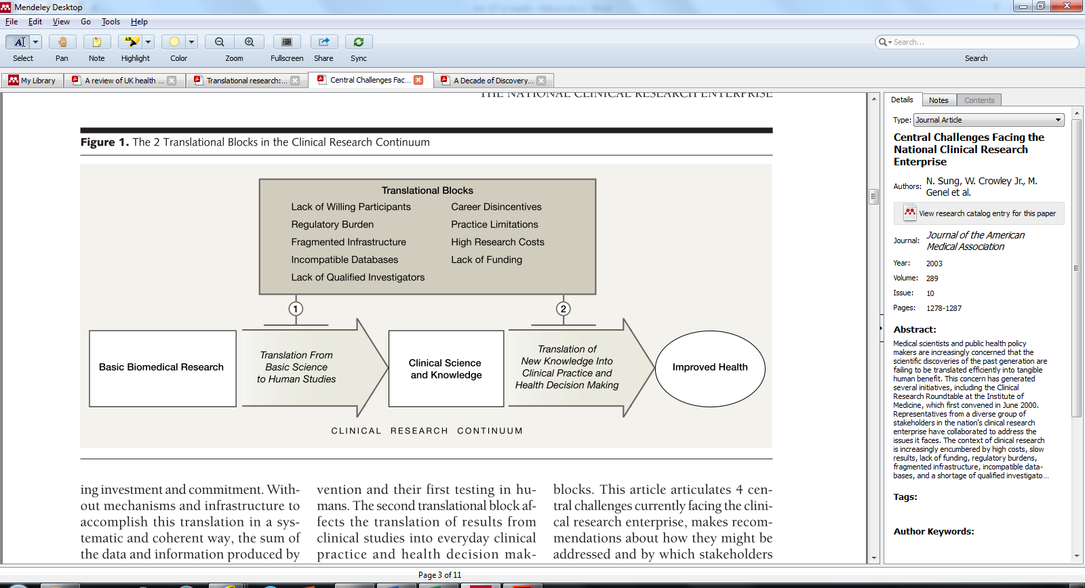

Source*: (Sung et al., 2003)*

In practical terms, T1 is to be solved in preclinical stages through clinical trials when a new discovery occurs (for example, a new drug, a new diagnostic test or a new technique). T2, the second block, requires: (i) the evaluation of health technologies in major trials; (ii) research in health services; and (iii) a process of knowledge management to ensure its feasibility. Because of its simplicity, there are doubts about the TR scheme’s ability to address the complexity of the health field (Greenhalgh & Wieringa, 2011). At the core of this criticism lies the proposed linearity of the process: the TR model implies that knowledge production is a unidirectional and linear process, placing health research in permanent dependency on basic science, favouring the development of pharmaceutical products. It primarily seeks to benefit patients at an individual level and does not emphasize public health needs (Ogilvie et al., 2009).

## Knowledge Translation model

KT is explicitly defined as a model which differs from TR. KT does not place the basic and biomedical sciences at the core of the translation process and proposes an alternative to linearity and unidirectionality, characteristics that are found in the knowledge transfer models described above (Johnson, 2005; Landry, Amara, Pablos-Mendes, Shademani, & Gold, 2006). KT models reflect the permanent back and forth of knowledge at different research stages. These models focus on ensuring clinical application of scientific evidence and shortens the typically lengthy periods needed to develop or adopt new scientific knowledge in health (Graham et al., 2006; Morris, Wooding, & Grant, 2011), linking them with the health system and with public health actions. Straus, Tetroe, & Graham (2009, p. 165)define Knowledge Translation as ‘*a dynamic and iterative process that includes the synthesis, dissemination, exchange and ethically sound application of knowledge to improve health, provide more effective health services and products, and strengthen the health care system’*. KT models include as actors: researchers and users of knowledge. Two representative models are described below: *Global KT Model*, and *Knowledge-to-Action Process*

* ***Global KT Model***

A first model is that proposed by the [Canadian Institutes of Health Research](http://www.cihr-irsc.gc.ca/e/193.html) (CIHR) called the ‘Global KT Model’. It establishes six actions for the research cycle (Sudsawad, 2007). These actions can facilitate translational processes by fostering interactions between users and/or research partners. The six steps have been synthesized as follows (Figure 5):

* KT1: defining research questions and methods;
* KT2: carrying out research (participatory);
* KT3: publishing in plain language and accessible formats;
* KT4: placing research findings in the context of other knowledge and sociocultural norms;
* KT5: making decisions and acting informed by research findings;
* KT6: influencing subsequent rounds of research based on the impacts of knowledge use.

***Figure 5. Global KT Model***

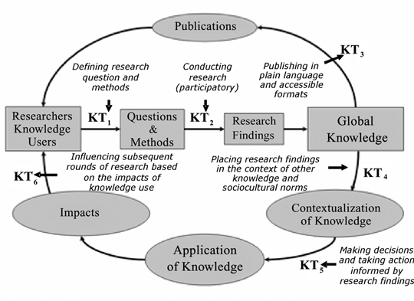

*Source: Sudsawad (2007)*

KT models make social context explicit including researchers’ and knowledge users’ interactions which are mediated by cultural factors and institutional conditions. Knowledge users are recognized as actors with some degree of influence on translational processes; they are not just passive receivers of products or services. This model also takes into account that multiple actors participate in the production and use of health knowledge (Grimshaw et al., 2012), namely: researchers, policy makers, and users.

* ***Knowledge-to-Action Process***

Another KT model is the Knowledge-to-Action Process (KTA) which was proposed by Graham et al. (2006). The KTA has had considerable institutional and academic impact; it is intended to encompass all possible outcomes of using clinical practice, technological knowledge and the dissemination of results in a single action model. KTA is fundamentally concerned with the process of knowledge implementation; it defines continuous cycles of action which can be implemented from knowledge syntheses derived from different knowledge generation processes (Figure 6). KTA’s steps include: identifying problems, adapting knowledge to local contexts, assessing barriers and facilitators for the use of knowledge, selecting specific measures for implementation, monitoring and evaluating the use of knowledge and its results, and promoting continuous use of knowledge over time.

***Figure 6.* Knowledge-to-action process**

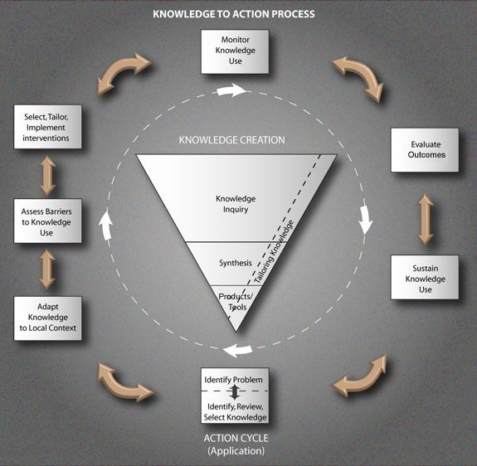

*Source: CIHR (2017)*

The KTA model is the result of a synthesis based on the review of more than 30 theories of research use, action research and knowledge transfer. It emphasizes contextual understanding, identifying barriers and facilitators as in the ‘Ottawa Model of Research Use’ (OMRU) or the ‘Promoting Action on Research Implementation in Health Services Framework’ (PARIHS) (Sudsawad, 2007).

In KTA, the knowledge creation phase consists of three approximations to knowledge (questions, syntheses and tools). It is represented as an inverted funnel, that reflects how knowledge is decanted into specific tools and/or products that allow their application (Sudsawad, 2007). Knowledge users’ needs can be incorporated into any of the knowledge creation phases, either by adapting research questions or by contributing to the identification of problems or issues relevant in the local context. Although the KTA model is conceptually rich and interesting, its implementation is not simple (Coutinho & Young, 2016), since KTA is infeasible without strong institutional support.

TR and KT have been developed outside the discussion of innovation in the economic sciences. For example, health field models do not regularly use the concept of innovation or consider it to be their main outcome. Health outcomes are conceived in multiple ways depending on the characteristics of the implementation: whether it is clinical, biomedical or a public health strategy, but how the productive sector is included in this process is not considered.

## Comparison across translation models in health disciplines

Based on a revision of TR and KT models, we assess how knowledge use is interpreted in the health disciplines using the analytical dimensions proposed in section 2. We summarize this exercise in Table 2.

**Table 2. Actors, interactions, process and institutional framework in selected translation models in health disciplines**

|  |  |  |  |
| --- | --- | --- | --- |
|  | *Translational Research* | *Knowledge Translation* | |
| *Model* | **Translational blocks in the Clinical Research Continuum** | **Global KT Model** | **Knowledge-to-Action Process** |
| *Authors* | **Sung et. al (2003)** | **Sudsawad (2007)** | **Graham et. al (2006)** |
| *Analytical Dimension* | | | |
| *Actors* | - Not directly identified, but they imply:  *Scientific community.  *Policy makers  *Health service providers (clinicians and practitioners).  *Patients. | - Researchers.  - Knowledge users.  - Policy makers. | - Knowledge users.  - Knowledge producers. |
| *Interactions* | - Unidirectional.  - Defined by linear scientific research sequence. | - Feedback loops between different activities.  - Defined by the steps of the process. | - Bidirectional between phases of the action cycle.  - Feedback loops in the knowledge creation process. |
| *Process* | - Linear model from basic research to improved health.  - Research activities are linked to provide final solutions.  - Validated by patient use. | - Knowledge flows are organized around scientific research (linking researchers and knowledge users, to global knowledge).  - Impact evaluation validates knowledge use. | - Composed by two sub-processes: action cycle, and knowledge creation.  - Knowledge use evaluation is the validation mechanism. |
| *Institutional framework* | - Regulate the introduction of research outcomes in medical practice.  - Static and defined, clearly applied in the process. | - Regulate the introduction of research outcomes.  - Consider cultural and organizational factors. | - Regulate the introduction of research outcomes.  - Consider cultural and organizational factors. |

*Source: own elaboration.*

Table 2 shows the substantial complexity that characterizes healthcare knowledge. There is a clear specification of health knowledge activities, since health disciplines detail the scientific and technological steps (or phases) required to introduce new solutions. Highlighting the specificities of these activities and the actors that undertake them provides a comprehensive framework in which tailor-made policy strategies could be implemented. Models from the health disciplines have been expressly designed for health issues and do not carry the normative commitment of generalist models like those proposed by IS. TR models have a list of activities that characterize T1 and T2. KT models include specific phases of the research process applied to health topics and their methods to validate knowledge creation, diffusion and usage.

However, it is also clear that health knowledge is fragmented across different disciplines that rarely interact (Gaudet, 2013). This is an issue when we look at the translational models and their scope. Three arguments are relevant here. First, the productive sector is not included in any of these models which means that they oversimplify the transition from discovery in the lab (or any other phase) and the technological and production capabilities needed to convert them into useful and accessible outcomes. Second, TR models exhibit a high degree of linearity. In the innovation literature, we find sound evidence against linear innovation models as they do not recognize the feedback loops between different stages, and places basic science as the only starting point (Godin, 2006). KT models partially overcome this linearity since they consider different starting points in the process; but do not include all the activities and actors required to incorporate this new knowledge into the medical practice. Third, KT models include the public sector only in a limited way because they do not expressly consider its influence in the definition of the research agenda.

# Dialogues between health innovation studies and health disciplines approaches for knowledge use

It is evident that health innovation studies and the health disciplines have a different focus. The health scientific community is oriented towards the idea that the advancement of pure knowledge will bring most of the benefits for population’s health. The lack of specificity of health innovation studies makes it difficult to close this gap. We argue that the construction of a dialogue between health innovation studies and the health disciplines is an important step to foster knowledge application. Both approaches have strengths and shortcomings that condition the perception of the health benefits from STI activities. Based on the analysis of the two perspectives, in this section, we focus on their complementarities. Our analysis considers the dimensions specified earlier: actors, interactions, process and institutional frameworks. Table 3 summarizes our proposed framework.

## Actors

Actors in healthcare activities are highly heterogeneous. Translational models focus on the description of the process, but they do not refer to interactions among actors and, hence, the actor description is not fully specified. In contrast, Health innovation models are more centred on the actor description, but they provide an economic interpretation of them and define them in terms of their participation in productive activities. They recognize two important actors: the public sector, in which policy makers play a central role, and the productive sector, where the capabilities are that are needed to transform health knowledge outcomes into product and services; with the latter mainly provided by firms.

Both approaches converge in considering two important actors: (i) the scientific community as a key player including universities, research centres and institutions, health research institutes, and research hospitals; and (ii) health service providers, namely, care hospitals, medical care centres and laboratories.

The final relevant actors are patients, defined as final beneficiaries of knowledge applications. This focus on patients as final receptors keeps the system depicted in these models oriented towards improving people’s health. In health innovation studies, patients are perceived solely as representing the demand side and are sometimes compared with consumers. The health disciplines, in turn, consider the patients’ health conditions on an individual level, neglecting the possibilities of applying collective solutions. These solutions may target the whole population and may end up being at least as efficient as solutions for each person.

We argue that the patient focuses in both approaches makes invisible other possibilities of knowledge applications (such as policy design or reformulation, changes in medical curricula, or restructuring of health services) (Etzkowitz & Rickne, 2014). In order to address this issue, we propose the definition of two dynamic actors: *knowledge users* and *knowledge beneficiaries*. These actors are not *a priori* defined sets; their specification depends on the type of problem that is being dealt with. *Knowledge users* are those actors that will apply and play with health knowledge. They might be a policy maker who is interacting with the scientific community to adjust a specific regulation, a researcher that is making use of a new technique to determine glucose levels, or a patient who is learning how to self-administer a new treatment. *Knowledge beneficiaries* are actors that increase their welfare status thanks to health knowledge applications. They could be the population that will benefit from a policy measure, the scientific community that will have faster access to publications on glucose thanks to a new test, or the patient who is self-administering the new treatment. *Knowledge users* and *Knowledge beneficiaries* are not mutually exclusive.

## Interactions

Actors’ interactions are also heterogeneous. They cannot be observed in translational models since these interactions are not part of the model. Health innovation models point out how actors might be connected and the nature of their linkages. The problem with health innovation studies is that this approach does not recognize the hierarchical structure of the relationships created in healthcare activities. These hierarchies come from actors’ capabilities and institutional asymmetries.

Unlike other many other activities, healthcare regulations are in place to prevent the application of new knowledge until it is proven safe for humans. Regulations imply that knowledge validation processes play a decisive role in the determination of knowledge applications. This process is managed in the first stage by the health scientific community which becomes the primary doorway to decide whether a new application should be in place or not. In a second (and related) step, policy-makers must approve the implementation of the knowledge application. Regulations create hierarchies in which the scientific community and the policy-makers are the gatekeepers of the process.

The different levels of capabilities among actors is another source of hierarchies. The scientific community and health services providers are normally identified as the most knowledgeable actors in healthcare activities; they are the ones entitled to evaluate new drugs, prescribe them, conduct surgeries or determine new treatments. As they are the ones validating knowledge use and its expected benefits, they have a power position over *Knowledge users* and *Knowledge beneficiaries*.

Hierarchies may foster or hamper knowledge flows. In order to understand how to deal with these hierarchical situations, we propose that *asymmetrical interactions* are a way to evaluate actors’ different positions in the process. This recommendation indicates the necessity of understanding the actors’ agendas and establishing negotiation processes to decide how to manage the knowledge application process in healthcare activities.

## The process

Health innovation studies fail to fully consider healthcare activity characteristics. They normally create adaptations from activities in other economic sectors and then try to accommodate healthcare actors and their interactions within these analytical frameworks. Therefore, they outline a process that does not contemplate all the learning processes needed to achieve knowledge validation and to move to closer stages of knowledge application in health care. What they do recognize is the requirement for production capabilities to transform new knowledge into products and services, providing new tangible solutions or facilitating access to existing ones. This suggests that they have a focus on the utilization of market mechanisms in the validation process of knowledge applications.

Health discipline models do not consider how the productive sector takes part in the knowledge translation process. This is very much linked to the perception of the innovation process as a linear process which assumes that production activities are just an automatic step in the transformation of knowledge into solutions. This is one of the reasons why we argue that TR models are not of much benefit for health knowledge use. The other reason for not favouring TR models is their focus on basic science activities which are more uncertain, have longer time frames to be applied and are less oriented to a specific application problem. In contrast, KT models are designed to describe healthcare activities in a less linear fashion, offering a much more specific and adequate alternative. They also include a different set of alternatives to validate knowledge application, since they consider patients’ wellbeing as their main outcome.

Our approach is oriented to identifying complementarities between these approaches. We suggest that a more suitable path for knowledge application might comprise the following characteristics: (i) a specific and properly design description of healthcare activities and knowledge flows in which the actors’ learning processes are considered; (ii) inclusion of production capabilities, making clear the problems related to scale factors (from laboratory, to prototypes, to making products and services available) and other constrains associated with the productive sector; (iii) feedback loops that tackle the problems of linearity and deterministic models, highlighting that basic science should not be the only or main source for knowledge applications and that knowledge sources are distributed throughout the components of the model; and (iv) the consideration of non-market mechanisms in the health knowledge validation process.

## The institutional framework

Both approaches consider the institutional framework in a rather static way. Within formal institutions, regulation is considered as part of the context or as only affecting a part of the system; however, generally, formal institutions do play a fundamental role in the determination of knowledge application. We have discussed how health regulations can affect the way the interaction between actors takes place and we could add the effect that other formal institutions (Intellectual Property Rights, economic regulation, liabilities, etc.) have on the development of production activities.

Informal institutions are also of upmost importance. On the one hand, health decisions are rooted in people’s cultural and social backgrounds (Natera et al., 2017; Soares Couto & Cassiolato, 2013). The perception and opportunity for obtaining benefits is mediated by beliefs and lifestyles (Sáenz, 2015). Even if knowledge application occurs with respect to something other than a medical treatment, as in policymaking, its possibilities of success will also be dependent of the adoption and adequate execution by the other system actors. On the other hand, the development of local capabilities calls for the consideration of socio-institutional conditions in which learning processes occur.

Table 3 synthetizes this discussion of the complementarities between knowledge use in health innovation studies and the health disciplines.

**Table 3. Complementarities between knowledge use in health innovation studies and health disciplines**

|  |  |  |  |
| --- | --- | --- | --- |
|  | Health innovation Studies approach | Health discipline approach | Complementarities between the two approaches |
| *Analytical Dimension* | | | |
| *Actors* | - Focuses on actors.  - Recognizes the public sector, the productive sector, the scientific community, and health services providers.  - Equal patients to consumers. | - Less focus on actors.  - Recognizes scientific community, and health services providers.  - Characterization of health service providers is very detailed.  - Actions oriented to individual patients. | - Recognition of public sector, productive sector, scientific community, health services providers.  - Definition of two dynamic actors: knowledge users and knowledge beneficiaries. |
| *Interactions* | - Focus on describing interaction among all different actors.  - Do not consider the hierarchical dimensions of the interactions. | - Place hierarchical interactions from the scientific community and policy makers to the rest of the system.  - Do not explicitly consider hierarchies between patients and medical practitioners. | - Consideration of asymmetrical interactions. |
| *Process* | - Generic innovation process adapted to healthcare activities. Lack of specificity.  - Consideration of the productive sector as the provider of health products and services.  -Market mechanisms validate knowledge use. | - Greater level of specificity: ad-hoc models to describe healthcare activities.  - Linear model of innovation: focus on basic sciences.  - Knowledge is validated according to its use in patients’ benefits. | - Generation of specific models for healthcare activities.  - Consideration of the productive sector.  - Inclusion of feedback loops to avoid linearity: knowledge sources are distributed in the model.  - Generation of different validation mechanisms for knowledge use (including, but not limited to market dynamics). |
| *Institutional framework* | - Regulation is part of the context or affects part of the system.  - Socio-cultural background is considered in the capability building process. | - Regulation is part of the context.  - Informal institutions are neglected. | - Consideration of formal institutions (regulations also affect productive activities).  - Consideration of informal institutions (socio-cultural background). |

Source: Own elaboration

# Conclusions

We have discussed how health innovation studies and the health disciplines understand knowledge application. The objective has been to establish a dialogue between these two approaches and to highlight their complementarities using a systemic framework.

We presented four models that explain how health activities are studied from health innovation systems: one oriented to product innovations (Consoli and Mina, 2009), one oriented to service innovation (Windrum and García-Goñi, 2008), and two focused on inclusive development (Chataway *et al.*, 2010; Soares Couto and Cassiolato, 2013). These models tend to fall short of including health specificities and are biased towards ensuring access to health products and services, making invisible the possibility of using health in non-market related mechanisms. Their focus on describing actors and their interactions and the inclusion of the productive sector are the main contributions that health innovation studies can offer.

The health disciplines understand knowledge application through translational models. TR is a linear model that goes from basic science to knowledge application in patients (Sung et al., 2003). KT models present a non-linear model which aim at fostering knowledge circulation through different health activities (Graham et al., 2006). Translational models do not specify actors’ interactions. In addition, they do not consider the productive sector and its roles in the generation of products and services, and they are centred on patient treatment on an individual level, neglecting the possibilities of collective solutions. Nevertheless, we argue that they add a good deal of specificity about healthcare activities (phases, steps, regulatory affairs, and characterization of health service providers) and the consideration of non-market knowledge applications to the discussion.

Using a systemic perspective, the main contribution of this paper is to propose four analytical dimensions contributing to a dialogue for understanding health knowledge applications: actors, interactions, processes and institutional framework. In relation to *actors,* we propose the recognition of the public sector, the productive sector, the scientific community, and health services providers, and the definition of two dynamics actors: knowledge users and knowledge beneficiaries. These two dynamics actors account for the different applications that knowledge might have. In terms of *Interactions*, we recommend considering them as asymmetrical based on institutional and capability asymmetries. We argue that an understanding of the *process* should be based on specific models of healthcare activities and learning processes, using market and non-market validation mechanisms. Finally, we propose the consideration of formal institutions (regulations also affect productive activities), and informal institutions (socio-cultural background) in the *institutional framework*.

These four analytical dimensions are not intended to offer *the* unified framework for health knowledge use. We offer them as a phase that precedes the definition of the analytical framework; they are intended as conceptual input. Healthcare issues are highly complex; they need problem and context specific analytical frameworks in which actors, interactions, processes and institutional frameworks can be configured in a tailor-made manner. We acknowledge the huge differences in health issues as between developing and more advanced countries. However – and unfortunately, health inequalities are not limited to the less developed regions and the problems we identify in existing models are present in countries at all ranges of income levels (Marmot, 2005). The consideration of the four analytical dimensions at different development levels could shed light on the characteristics of health knowledge application and serve as a starting point for policy learning between countries or regions.

Furthermore, by conducting applied research following our recommendations, the four analytical dimensions could be amplified. From our conceptual exercise in this paper, new questions arise: (i) what are the mechanisms to identify the dynamic actors and do they exchange roles during the learning processes? (ii) are there other relevant sources of hierarchies involved in actors’ interactions? If so, how do they relate to institutional and capabilities asymmetries?, (iii) how do market and non-market validation mechanisms relate to each other and what do they imply in terms of learning processes?, and finally (iv) how do we balance formal and informal institutions in a comprehensive institutional framework? As we surely fall short in outlining all of the possible questions arising from this analysis, we send an open call to debate the issues raised in this paper further.

Our intention is to propose the four dimensions - actors, interactions, process and institutional framework - as a first step towards establishing a dialogue that aims at fostering health knowledge application. We recognize that our theoretical contribution is only one component of such a task. This dialogue requires multidisciplinary collaboration in which contributors from health innovation studies and the health disciplines can discuss their proposals and concerns. The possibilities for better use of health knowledge demand this discussion and future agreement.

**Acknowledgements**

We acknowledge the support of the CONACYT through Project, *Transferencia de Conocimiento Orientada Hacia Problemas Nacionales de Salud: el Caso de la Diabetes*, funded by Fondo de Ciencia Básica (CB2015-258387). We also thank the two anonymous reviewers and the editor, Robin Mansell, for comments that helped to improve this papert. Any errors that remain are our sole responsibility.

# 

# References

Arocena, R., & Sutz, J. (2000). Looking at national systems of innovation from the South. *Industry & Innovation*, *7*(1), 55–75. https://doi.org/10.1080/713670247

Arocena, R., & Sutz, J. (2012). Research and innovation policies for social inclusion: an opportunity for developing countries. *Innovation and Development*, *2*(1), 147–158. https://doi.org/10.1080/2157930X.2012.663583

Casas, R. (2005). Exchange and knowledge flows between large firms and research institutions. *Innovation*, *7*(2–3), 188–199.

Cassiolato, J. E., & Lastres, H. (2007). Innovation and innovation systems: relevance for the area of health. *Electronic Journal of Communication, Information & Innovation in Health*, *1*(1), 151–160.

Cassiolato, J. E., & Lastres, H. M. M. (2000). LOCAL SYSTEMS OF INNOVATION IN MERCOSUR COUNTRIES. *Industry & Innovation*. https://doi.org/10.1080/713670250

Chataway, J., Hanlin, R., & Kaplinsky, R. (2014). *Inclusive innovation: an architecture for policy development*. *Innovation and Development*. https://doi.org/10.1080/2157930X.2013.876800

Chataway, J., Hanlin, R., Mugwagwa, J., & Muraguri, L. (2010). Global health social technologies: Reflections on evolving theories and landscapes. *Research Policy*, *39*, 1277–1288. https://doi.org/10.1016/j.respol.2010.07.006

Consoli, D., & Mina, A. (2009). An evolutionary perspective on health innovation systems. *Journal of Evolutionary Economics*, *19*(2), 297–319. https://doi.org/10.1007/s00191-008-0127-3

Coutinho, A., & Young, N. (2016). Science transformed? A comparative analysis of ‘societal relevance’ rhetoric and practices in 14 Canadian Networks of Centres of Excellence. *Prometheus (United Kingdom)*, *34*(2), 133–152. https://doi.org/10.1080/08109028.2017.1280936

Cozzens, S., & Sutz, J. (2012). Innovation in Informal Settings: A Research Agenda. *Ottawa: IDRC*. Retrieved from http://www.crdi.ca/EN/Lists/Publications/Attachments/1130/IID Framework July 29.pdf

Cozzens, S., & Sutz, J. (2014). Innovation in informal settings: reflections and proposals for a research agenda. *Innovation and Development*, *4*(1), 5–31. https://doi.org/10.1080/2157930X.2013.876803

Dosi, G. (1988). *Technical Change and Economic Theory*. Pinter Publishers. Retrieved from http://books.google.es/books?id=8vG3AAAAIAAJ

Dutrénit, G., Natera, J. M., Anyul, M. P., Vera-Cruz, A. O., & Torres, A. (2018). Dialogue processes on STI policy-making in Latin America and the Caribbean: Dimensions and conditions. *Science and Public Policy*, *45*(3), 293–308. https://doi.org/10.1093/scipol/scx044

Etzkowitz, H., & Rickne, A. (2014). Citizen-driven innovation: stem cell scientists, patient advocates and financial innovators in the making of the California Institute of Regenerative Medicine (CIRM). *Prometheus (United Kingdom)*, *32*(4), 369–384. https://doi.org/10.1080/08109028.2015.1126984

Freeman, C. (1987). *Technology, policy, and economic performance: lessons from Japan*. London: Pinter Publishers.

Gallouj, F., & Weinstein, O. (1997). Innovation in services. *ELSEVIER Research Policy*, *26*, 537–556. https://doi.org/10.1016/S0048-7333(97)00030-9

Gaudet, J. (2013). It takes two to tango: knowledge mobilization and ignorance mobilization in science research and innovation. *Prometheus*, *31*(3), 169–187. https://doi.org/10.1080/08109028.2013.847604

Gibbons, M., Limoges, C., Nowotny, H., Schwartzman, S., Scott, P., & Trow, M. (1994). *The new production of knowledge: The dynamics of science and research in contemporary societies*. Sage.

Godin, B. (2006). The Linear Model of Innovation: The Historical Construction of an Analytical Framework. *Science, Technology & Human Values*, *31*(6), 639–667. https://doi.org/10.1177/0162243906291865

González-Block, M. Á., Mercado, F. J., Ochoa, H., Rivera, H., & Idrovo, Á. J. (2008). The use of research by health managers in Mexico: the diagnostic and strengthening of capacity. *Salud Pública de México*, *50*(6), 498–507. https://doi.org/10.1590/s0036-36342008000600010

Gordon-Strachan, G., Bailey, W., & Ward, E. (2006). Linking researchers and policy-makers : some challenges and approaches. *Cadernos de Saúde Pública*, *22*, S69–S76.

Graham, I., Logan, J., Harrison, M. B., Straus, S. E., Tetroe, J., Caswell, W., & Robinson, N. (2006). Lost in Knowledge Map: Time for a Map? *The Journal of Continuing Education in the Health Professions*, *26*, 13–24.

Greenhalgh, T., Robert, G., Macfarlane, F., Bate, P., & Kyriakidou, O. (2004). Diffusion of innovations in service organizations: systematic review and recommendations. *Milbank …*, *82*(4), 581–629. https://doi.org/10.1111/j.0887-378X.2004.00325.x

Greenhalgh, T., & Wieringa, S. (2011). Is it time to drop the “knowledge translation” metaphor? A critical literature review. *Journal of the Royal Society of Medicine*, *104*(12), 501–509. https://doi.org/10.1258/jrsm.2011.110285

Grimshaw, J. M., Eccles, M. P., Lavis, J. N., Hill, S. J., & Squires, J. E. (2012). Knowledge translation of research findings. *Implementation Science*, *7*(1), 50. https://doi.org/10.1186/1748-5908-7-50

Hanlin, R., & Andersen, M. H. (2016). *Aalborg Universitet Health Systems Strengthening*. *Globelics Thematic Report*. Aalborg. https://doi.org/10.5278/241620502

Johnson, B., & Andersen, A. D. (2012). *Learning, Innovation and Inclusive Development: New perspectives on economic development strategy and development aid*. Aalborg Universitetsforlag.

Johnson, L. S. (2005). From knowledge transfer to knowledge translation: Applying research to practice. *Occupational Therapy Now*, *7*(4), 11–14.

Landry, R., Amara, N., Pablos-Mendes, A., Shademani, R., & Gold, I. (2006). The knowledge-value chain: a conceptual framework for knowledge translation in health. *Bulletin of the World Health Organization*, *84*(8), 597–602.

Lundvall, B.-A. (1992). *National Systems of Innovation Towards a Theory of Innovation and Interactive Learning*. London: Pinter.

Lundvall, B.-Å. (1992). *National Systems of Innovation: Towards a Theory of Innovation and Interactive Learning*. London: Pinter Publishers.

Lundvall, B.-Å. (1996). *The Social Dimension of The Learning Economy*. Rochester, NY. Retrieved from http://papers.ssrn.com/abstract=66537

**Lundvall, B.-Å. (2016). Postscript: Innovation System Research: where it came from and where it might go. In B. A. Lundvall (Ed.), *The Learning Economy and the Economics of Hope* (1st ed., pp. 223–266). London; New York: Anthem Press. Retrieved from http://www.jstor.org/stable/j.ctt1hj9zjd.14**

Lundvall, B.-Å., & Johnson, B. (1994). The Learning Economy. *Journal of Industry Studies*, *1*(2), 23–42. https://doi.org/10.1080/13662719400000002

Malerba, F. (2002). Sectoral systems of innovation and production. *Research Policy*, *31*(2), 247–264. https://doi.org/10.1016/S0048-7333(01)00139-1

Marmot, M. (2005). Social determinants of health inequalities. *The Lancet*, *365*(9464), 1099–1104.

**Matos, M., & Stallivieri, F. (2009). *Metodologia de pesquisa implementada pela Redesist.* Rio de Janeiro, Brasil: IE/RedeSist. Available at: http://www.ie.ufrj.br/intranet/ie/userintranet/hpp/arquivos/021220162352_MatoseStallivieri2016TextoMetodologiaAPLsLivro20anosRedeSist.pdf (Accesed on 06- February-2019)**

Metcalfe, J. S., James, A., & Mina, A. (2005). Emergent innovation systems and the delivery of clinical services: The case of intra-ocular lenses. *Research Policy*, *34*(9), 1283–1304. https://doi.org/10.1016/j.respol.2005.01.015

Morris, Z. S., Wooding, S., & Grant, J. (2011). The answer is 17 years, what is the question: understanding time lags in translational research. *Jrsm*, *104*(12), 510–520. https://doi.org/10.1258/jrsm.2011.110180

Mugwagwa, J., Hanlin, R., Chataway, J., & Muraguri, L. (2013). The Role of the Product Development Partnership as a Translational Mechanism for Delivering Health Solutions in Low-Resource Settings. *Translational Medicine: The Future of Therapy?*, 233.

Natera, J. M., Suárez, M., & Rojas-Rajs, S. (2017). Ciencia, Tecnología e Innovación para el desarrollo inclusivo en el sector salud. In J. M. Corona (Ed.), *Sociedad, desarrollo y políticas públicas I* (1st ed., pp. 301–329). Ciudad de México: Bonilla Artigas Editores y Universidad Autónoma Metropolitana.

Nelson, R. R. (2008). What enables rapid economic progress: What are the needed institutions? *Research Policy*, *37*(1), 1–11. https://doi.org/10.1016/j.respol.2007.10.008

Nelson, R. R., & Nelson, K. (2002). Technology, institutions, and innovation systems. *Research Policy*, *31*(2), 265–272. https://doi.org/10.1016/S0048-7333(01)00140-8

Nelson, R. R., & Sampat, B. N. (2001). Making sense of institutions as a factor shaping economic performance. *Journal of Economic Behavior and Organization*, *44*(1), 31–54. https://doi.org/10.1016/S0167-2681(00)00152-9

Niosi, J., Saviotti, P., Bellon, B., & Crow, M. (1993). National systems of innovation: in search of a workable concept. *Technology in Society*, *15*(2), 207–227. https://doi.org/10.1016/0160-791X(93)90003-7

OECD/EUROSTAT. (2018). *Oslo Manual 2018: Guidelines for Collecting, Reporting and Using Data on Innovation* (4th Editio). OECD Publishing, Paris / EUROSTAT, Luxemburgo: OECD Publishing. https://doi.org/10.1787/9789264304604-en

Ogilvie, D., Craig, P., Griffin, S., Macintyre, S., & Wareham, N. J. (2009). A translational framework for public health research. *BMC Public Health*, *9*, 116. https://doi.org/10.1186/1471-2458-9-116

Ramlogan, R., Mina, A., Tampubolon, G., & Metcalfe, J. S. (2007). Networks of knowledge: The distributed nature of medical innovation. *Scientometrics*, *70*(2), 459–489. https://doi.org/10.1007/s11192-007-0212-7

**Sáenz, M. del R. (2015). Equidad y determinantes sociales de la salud: reflexiones desde América Latina. *Programa EUROsocial*, *Colección* (Serie: Análisis, Área: Salud.). Available at: http://sia.eurosocial-ii.eu/files/docs/1445409020-Equidad%20y%20determinantes%20sociales%20de%20la%20salud.pdf (accesed on 06-February-2019).**

Saviotti, P. P., & Metcalfe, J. S. (1984). A theoretical approach to the construction of technological output indicators. *Research Policy*, *13*(3), 141–151. https://doi.org/10.1016/0048-7333(84)90022-2

Soares Couto, M. C., & Cassiolato, J. E. (2013). Innovation Systems and Inclusive Development: Some evidence based on empirical work. In *International Workshop and Journal Special issue on “New Models of Innovation for development”* (pp. 1–21).

Straus, S. E., Tetroe, J., & Graham, I. (2009). Defining knowledge translation Review. *Journal of the Canadian Medical Association*, *181*(3–4), 165–168. https://doi.org/10.1503/cmaj.081229

**Sudsawad, P. (2007). Knowledge translation: Introduction to models, strategies, and measures. Austin, TX: Southwest Educational Development Laboratory, National Center for the Dissemination of Disability Research. Available at: http://www.ncddr.org/kt/products/ktintro/ktintro.pdf (accesed on 06-February-2019).**

Sung, N. S., Crowley Jr., W. F., Genel, M., Salber, P., Sandy, L., Sherwood, L. M., … Rimoin, D. (2003). Central Challenges Facing the National Clinical Research Enterprise. *Journal of the American Medical Association*, *289*(10), 1278–1287. https://doi.org/10.1001/jama.289.10.1278

Tugwell, P., Robinson, V., Grimshaw, J., & Santesso, N. (2006). Systematic reviews and knowledge translation. *Bulletin of the World Health Organization*, *84*(8), 643–651. https://doi.org/10.2471/BLT.05.026658

Vinot, D., Ilinca, S., Espin, J., Hamer, S., Botje, D., Veloso Mentes, R., … Plochg, T. (2012). All you need to know about innovation in healthcare : the 10 best reads. *International Journal of Healthcare Management*, *5*(4), 193–202. https://doi.org/10.1179/2047971912Y.0000000018

WHO, OMS Neelam, S., Savedoff, W., Sengupta, A., Marie, A., López, R., … Kotlikoff, L. J. (2013). *The world health report 2013: Research for universal health coverage*. *World Health Organization Press*. Geneva. https://doi.org/10.2105/AJPH.2013.301254

Windrum, P., & García-Goñi, M. (2008). A neo-Schumpeterian model of health services innovation. *Research Policy*, *37*(4), 649–672. https://doi.org/10.1016/j.respol.2007.12.011

Yazdizadeh, B., Majdzadeh, R., & Salmasian, H. (2010). Systematic review of methods for evaluating healthcare research economic impact. *Health Research Policy and Systems*, *8*, 6. https://doi.org/10.1186/1478-4505-8-6

1. Globelics is a worldwide community of scholars working on innovation and competence building in the context of economic development (www.globelics.org).
2. Physical technologies are the set of material resources necessary for the generation of a product or service. In drug development, physical technologies would be the active components present in medicine. Social technologies consist of forms of human organization necessary for the production process, labour division, assignment of responsibilities and even the way in which the products or services will be used.
3. The knowledge transfer tradition has offered a linear vision in which the Academy was responsible of producing knowledge that firms should incorporate into their productive processes. Nevertheless, the concept has evolved, opening the door for transfer activities between different actors and in multiple directions (Casas, 2005).